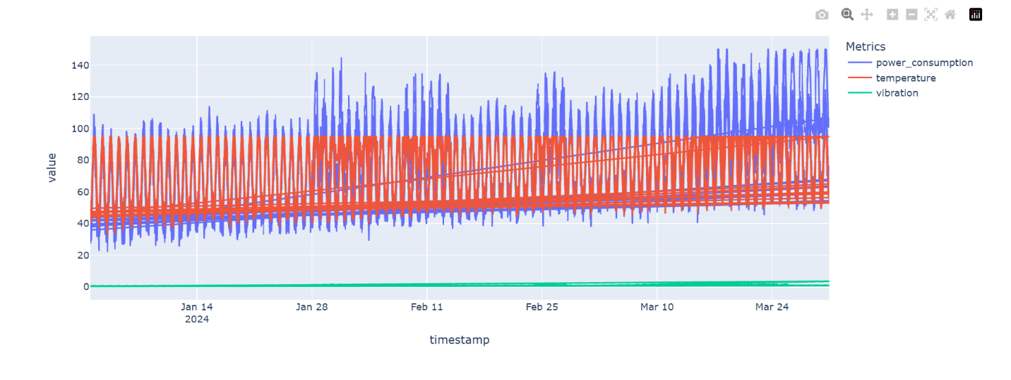
Description:
Condition reading based on the metrics selected by user across the entire rig/equipment

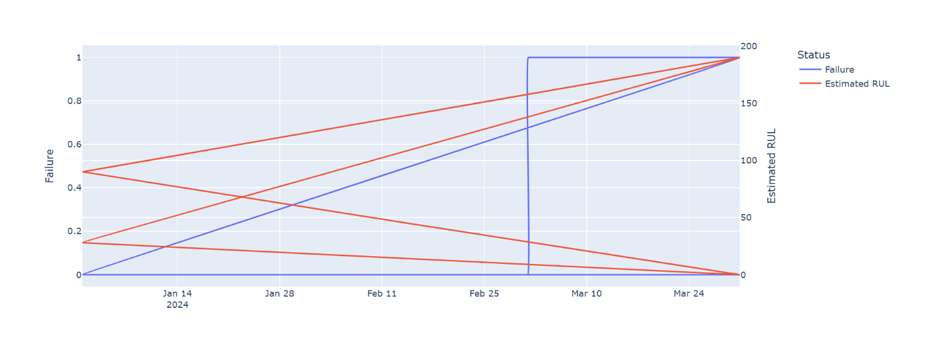
Description:
RUL reading based on the data, user input on the system

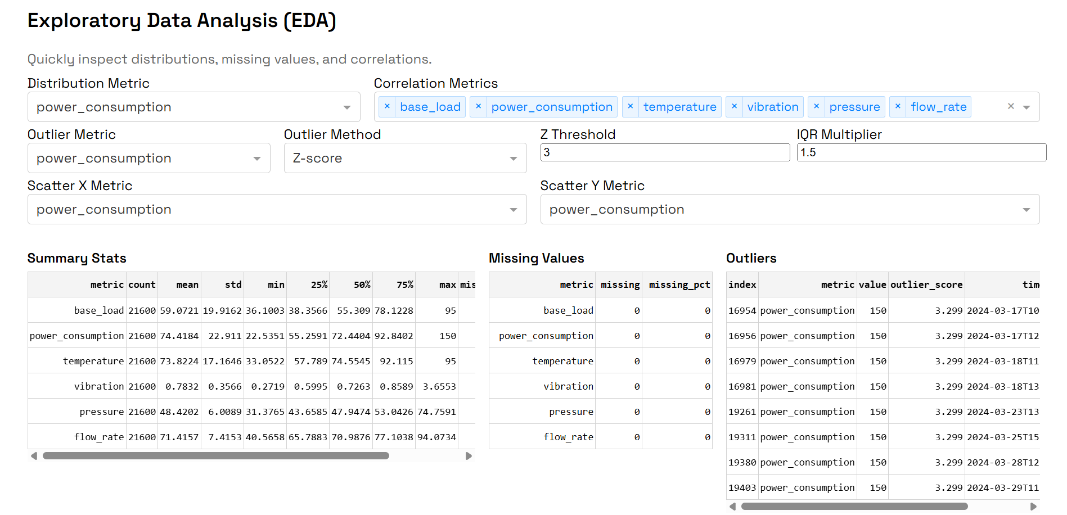
Description:
EDA, reading based on the data input from user

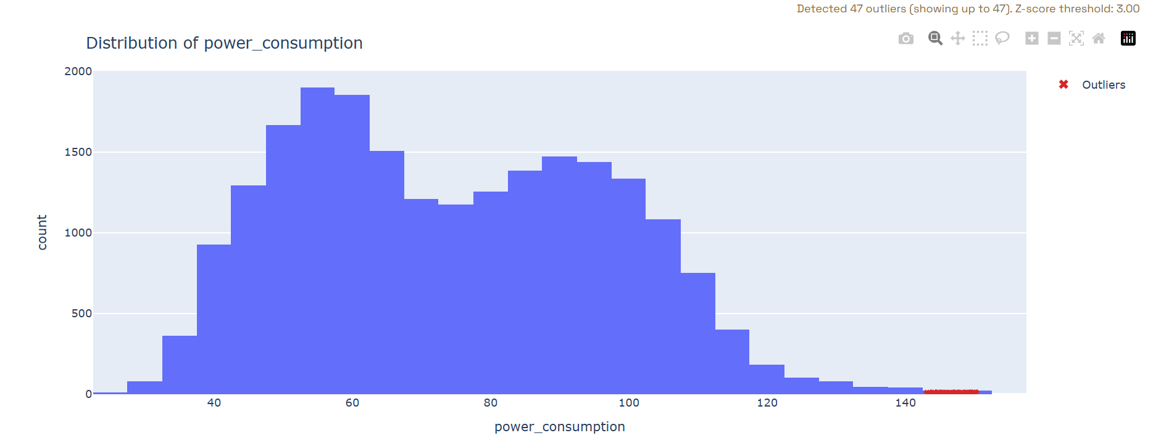
Description:
EDA1, Based on metrics user selected on control panel, and show the outliner, that overlap it can cause failure or accident

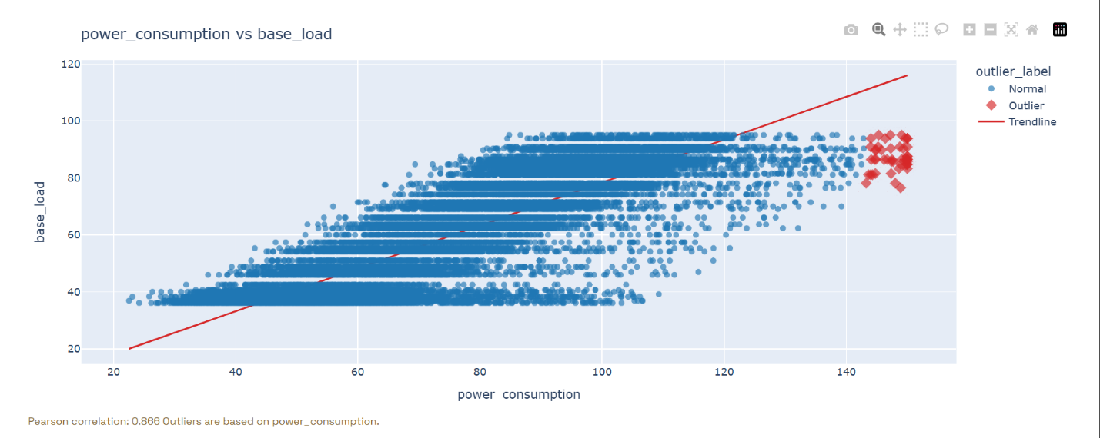
Description:
EDA2, based on the comparison metrics that user have select on the control panel system

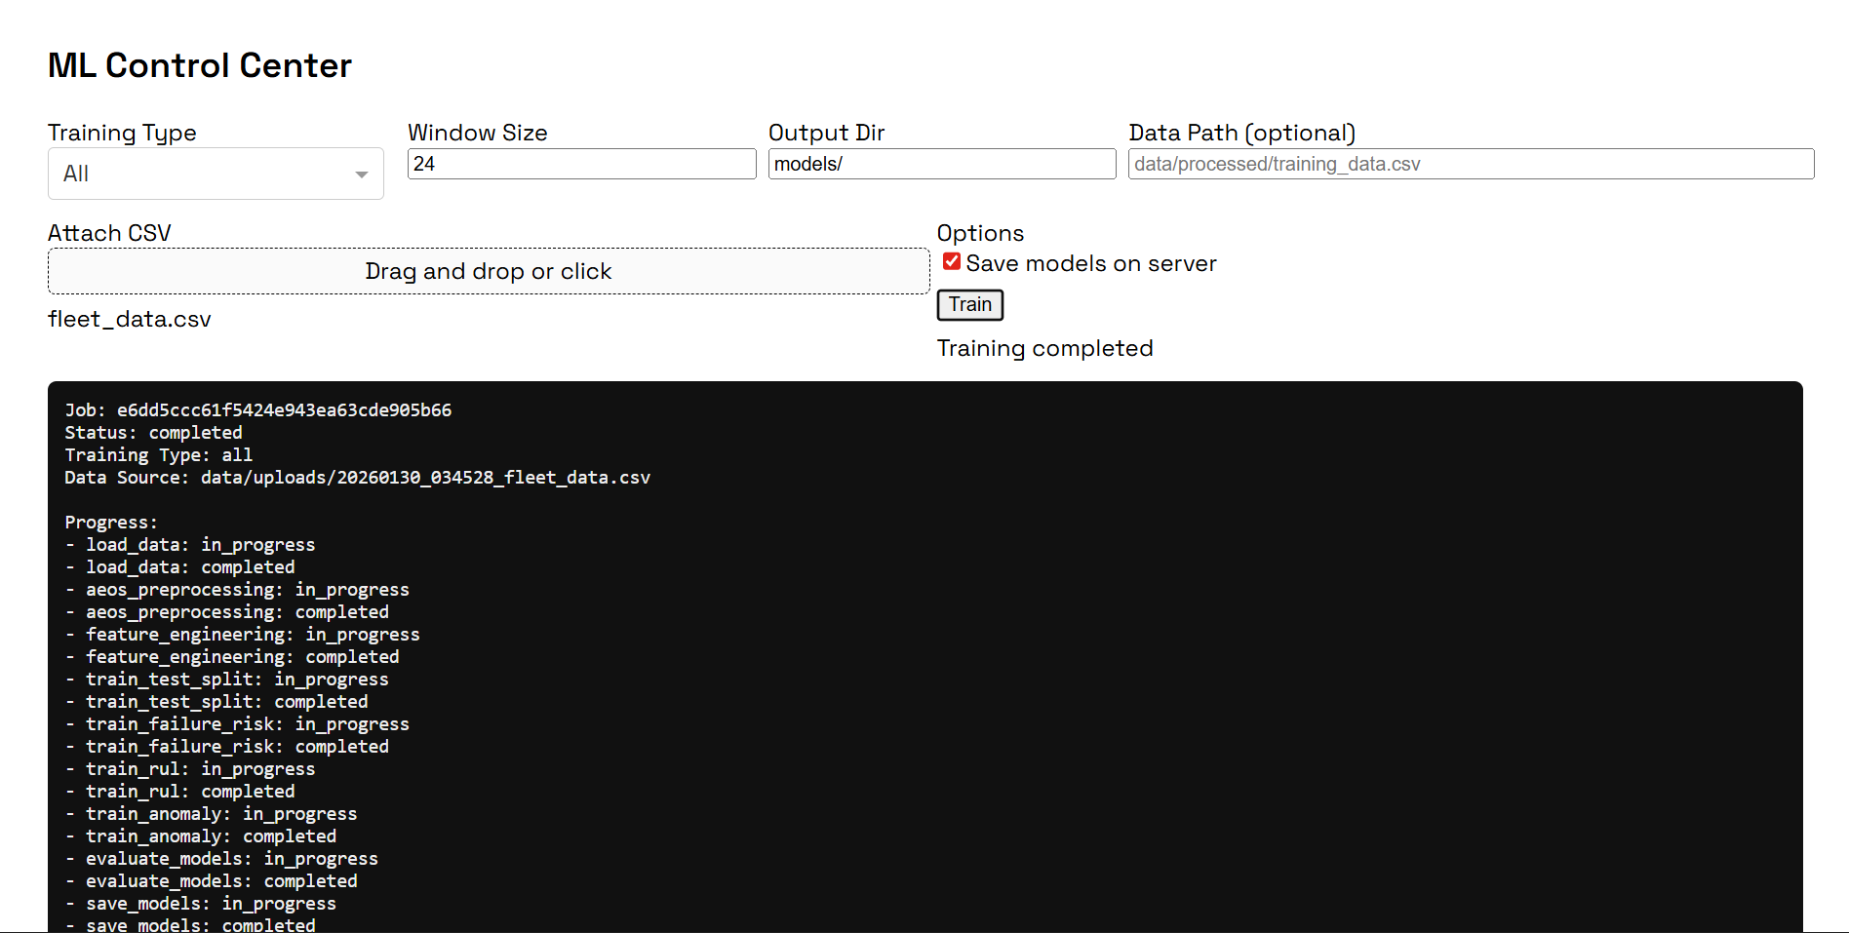
Description:
ML, or Machine learning control panel that allows user to train their own ML based on the data there have
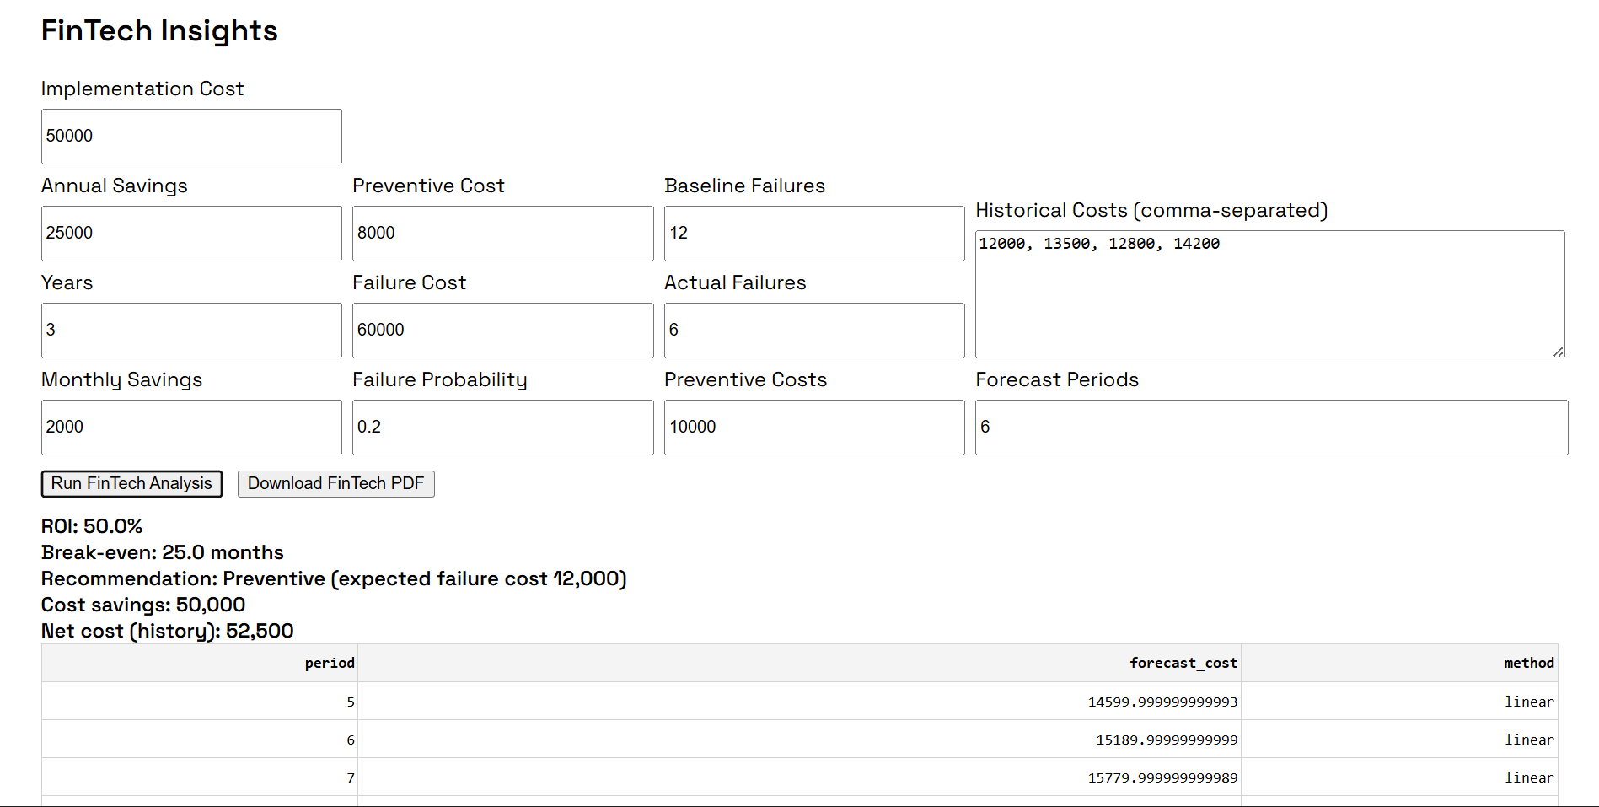
Description:
Fintech insight, ruled for give the user decision making, to make their cost more efficient, user can download their Fintech report in this section, for report references

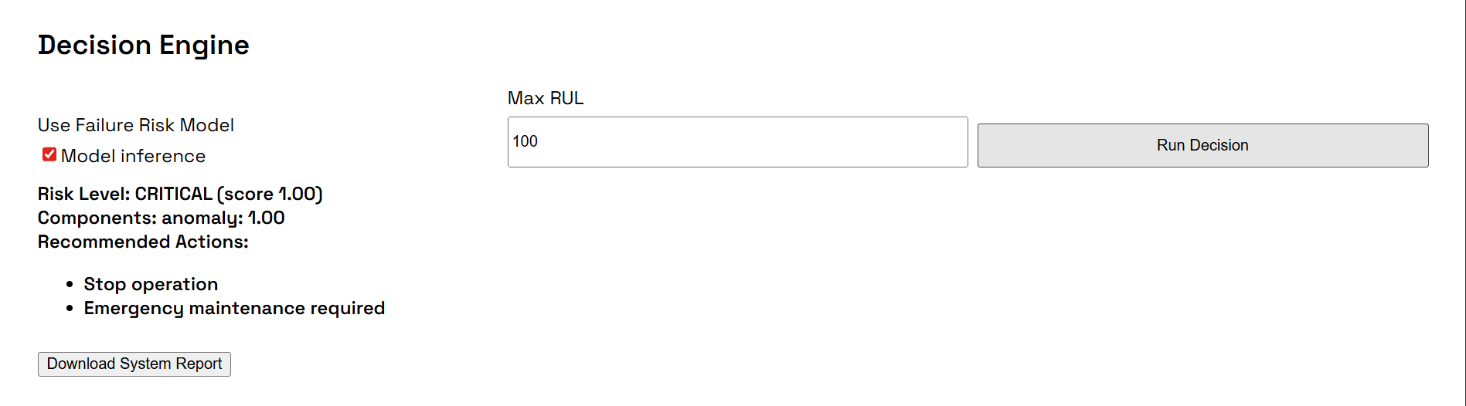
Description:
Decision Engine Section is function to give the user Decision platform to what should they do based on the Max RUL their give, the user also can download the system reading report in this section

